1. Install git.

Go to browser search for download git and click on git for windows.

Download the git for the windows

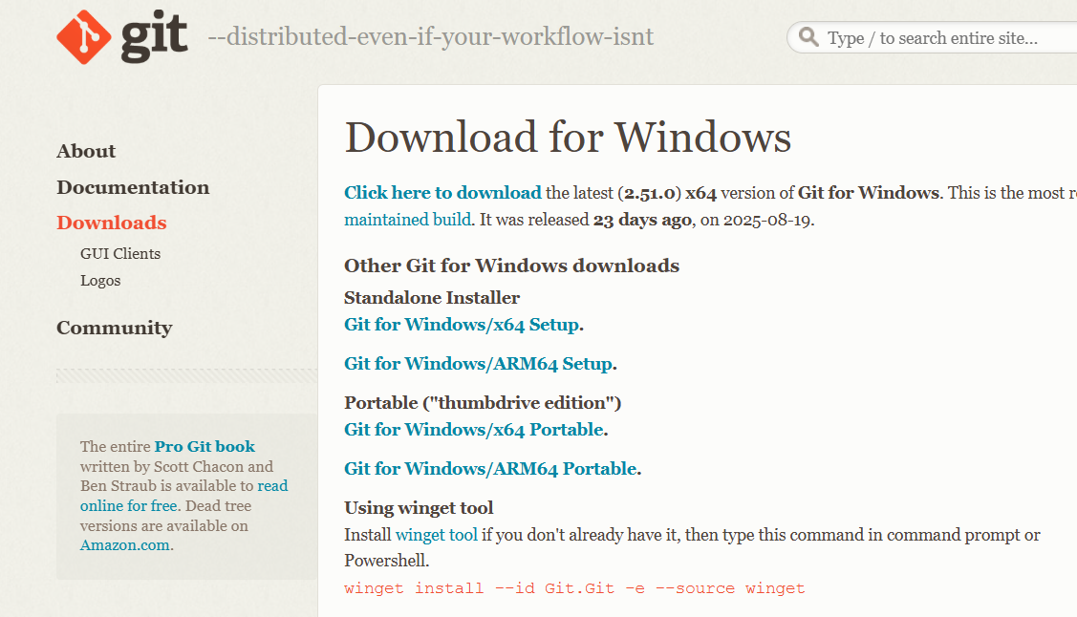

After downloading open and run the file then click on install the git will be installed

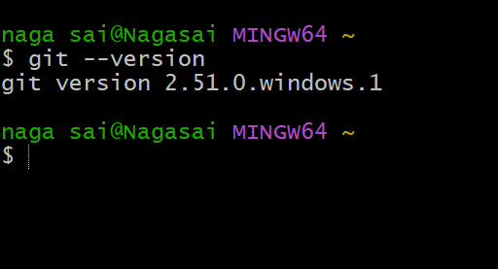

2.Create a repo in github with README.md and .ignore file.

To create README.md go to the reposiry in git hub scroll down you can see the add README click on README also add .gitignore file.

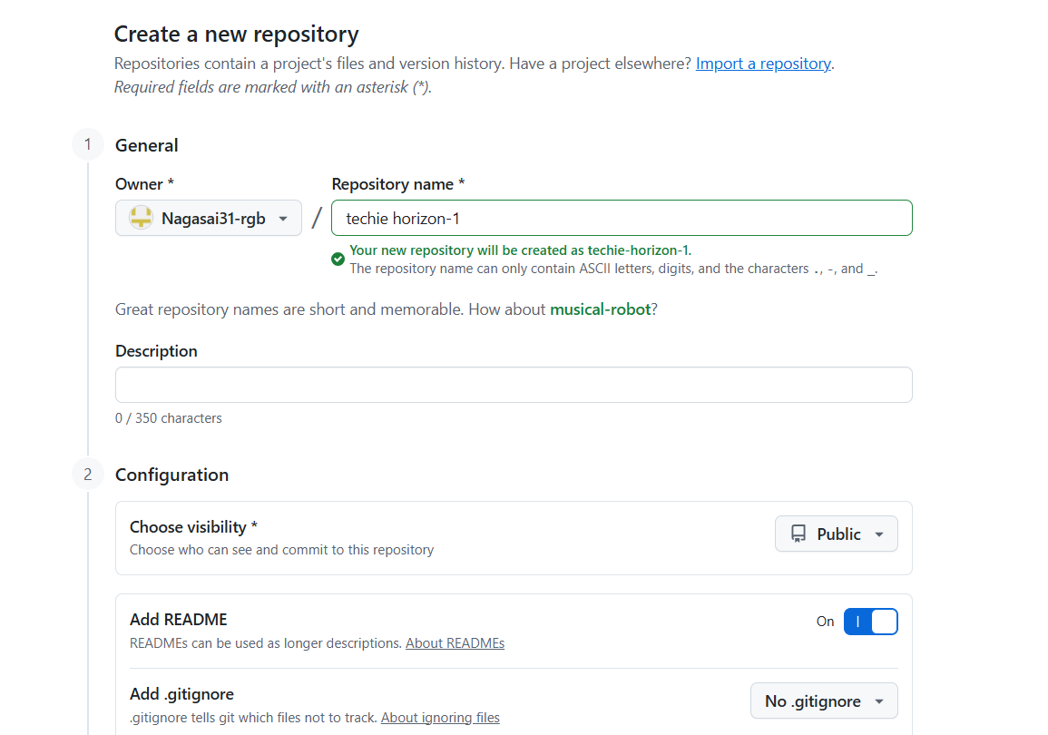

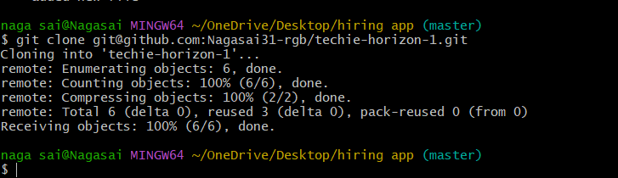

3.Clone the created repo to local.

USE git clone -b “branch name” “url of the repo” – to clone the documents of the repo to the local machine.



4.Create two files in local repo.

Create two files using touch command

Use GIT ADD to add files to local repo.

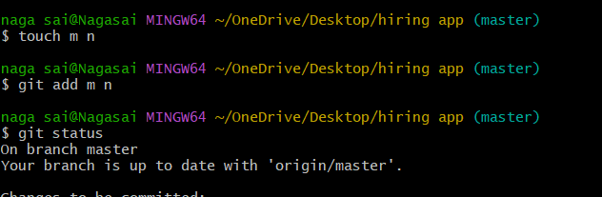

5.Commit two files and push to central Repository

Git commit -m “message” to commit the changes you have made

Check the status : git status – see working tree clean.

Git log : to see the logs

Git push : to push the changes from local machine to the central repo

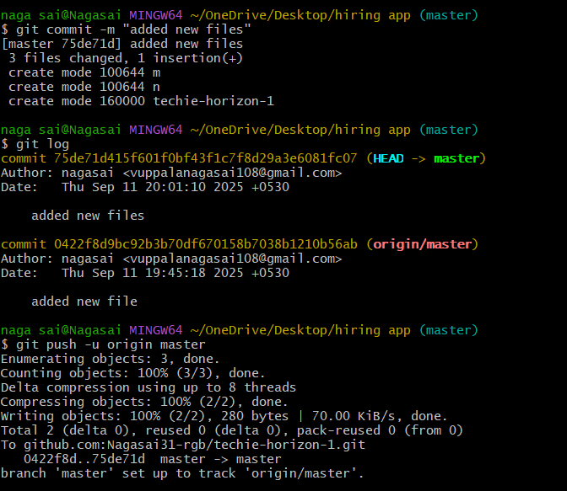

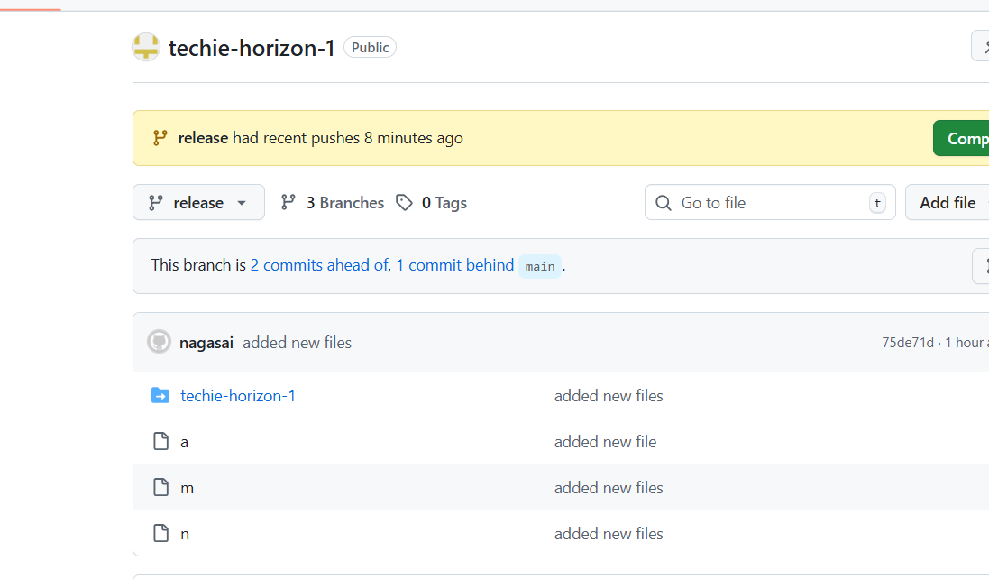

6.Create a branch in local and create a sample file and push to central.

Git branch “name” ; to create a new branch

Git branch –list : to list the branches available * means you are using the branch

Git checkout “name” : to switch to the branch

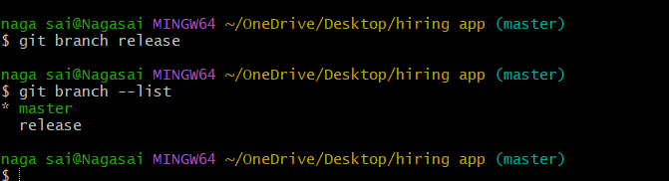

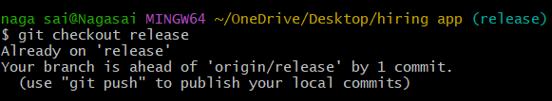

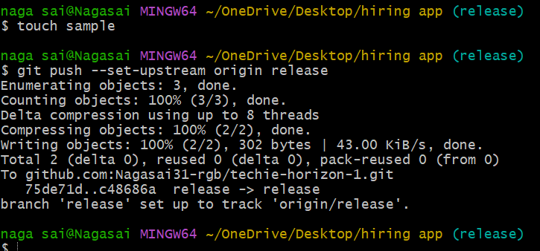

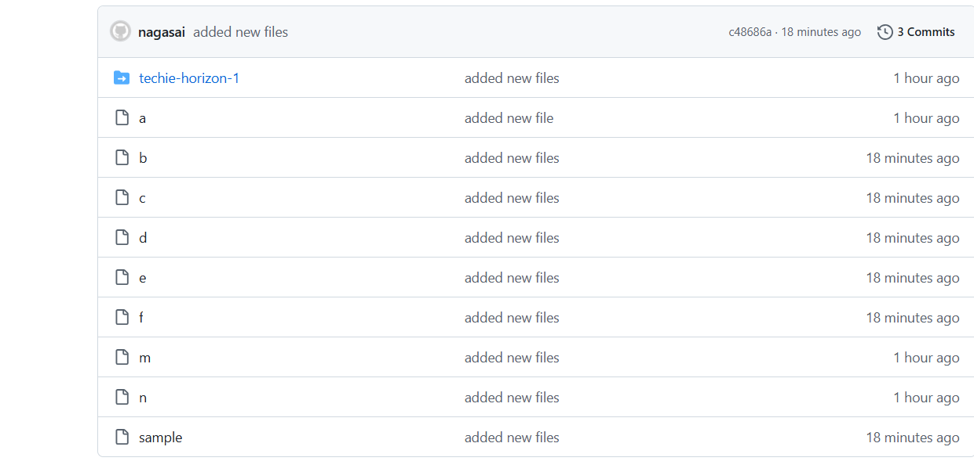

7) Create a branch in GitHub and clone it to the local repository.

Click on new branch and create new branch

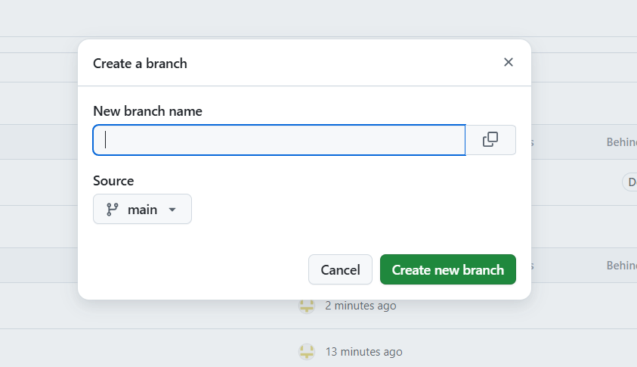

Git clone -b “branch name” “ssh url” – to download the specific branch to local macine

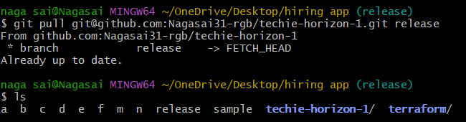

8.Merge the created branch with master in git local

Git merge “branchname” : to merge the branches with master in git local.

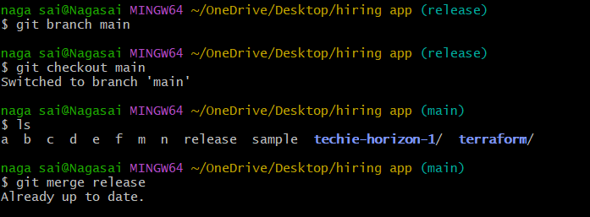

9.Merge the created branch with master in github by sending   
a pull request.

Go to GitHub Repository

Open your repo on GitHub.

You’ll usually see a prompt like: “Compare & pull request” for your branch .

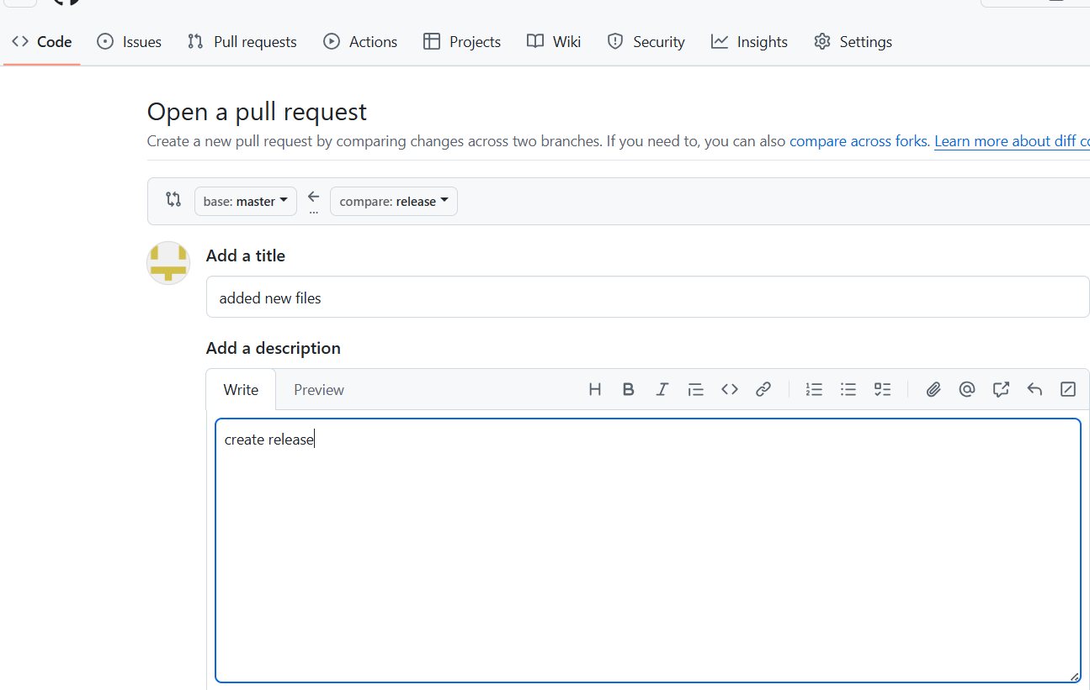

Click “Merge pull request”.

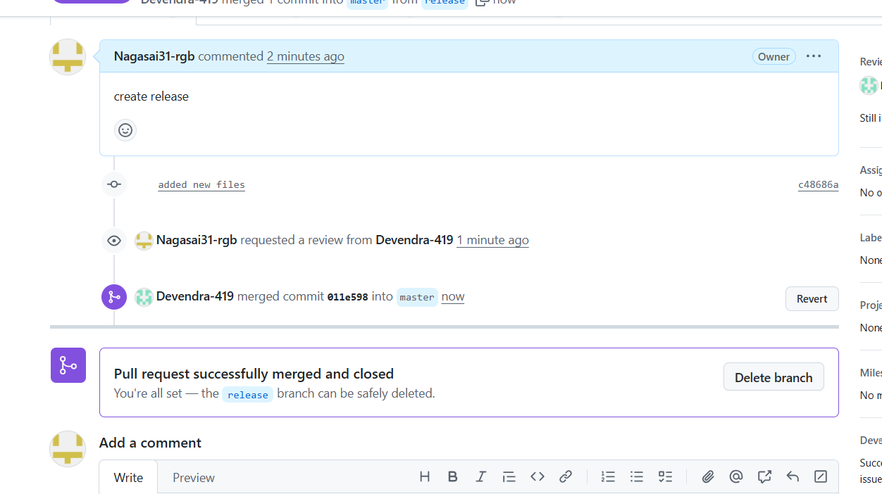

10.Create a file in local and send that to branch in github.

Git commit -m “messege “ commit the changes and add message

Git push -u origin master : to push the file from local to the branch in git hub

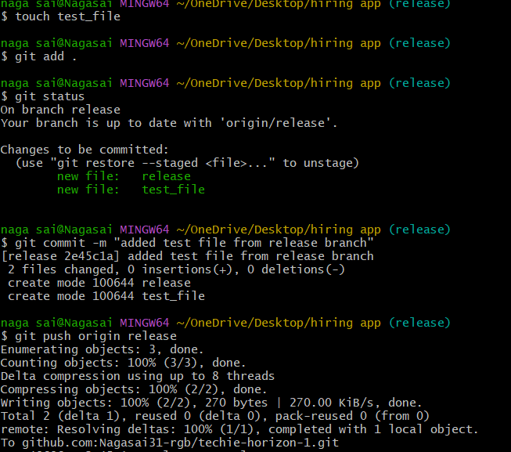

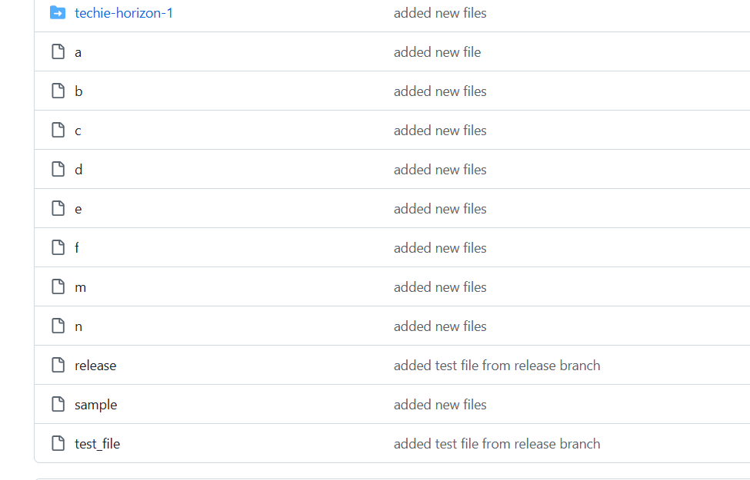

12.Create a file with all passwords and make that untrackable with git.

Create ignore file : vi .gitignore

Git add . : to update the git

Git status : you can see the password file is being untracked.

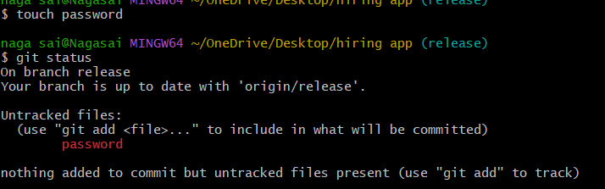

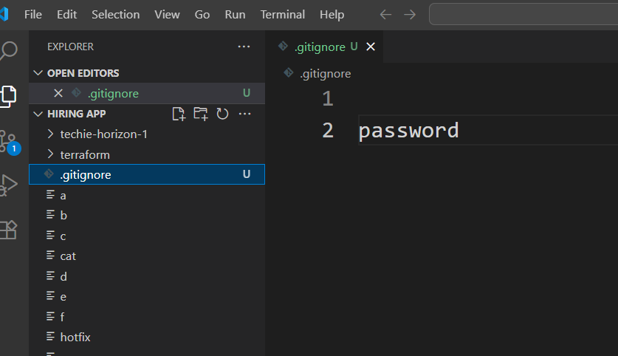

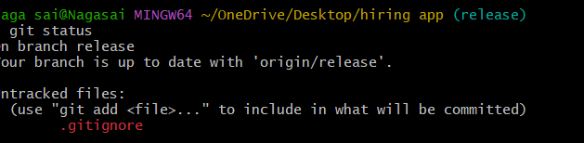

13.Make a commit and make that commit reset without savings changes.

Git add . : to make the changes trackable

Git commit : to commit the changes ,Copy the git commit

Git reset - -hard commit id : to reset thecommit without saving changes

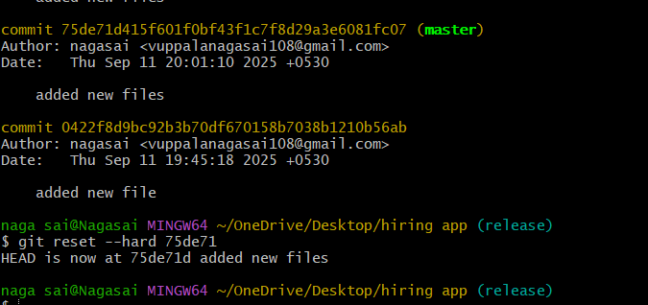

14.Revert a commited commit to the older version.

Git revert <commitid> :revert the changes

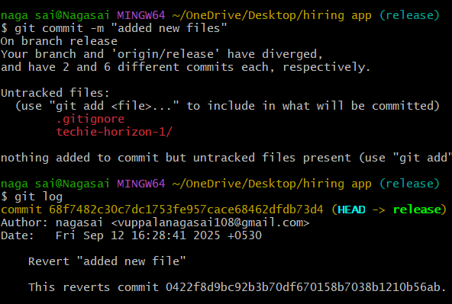

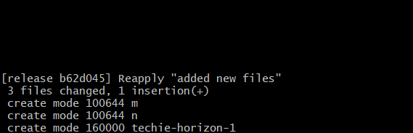

15.Push a file to stash without savings the changes and work on another file.

touch new :create new file.

git add .

Git stash : move the file to the stash memory.

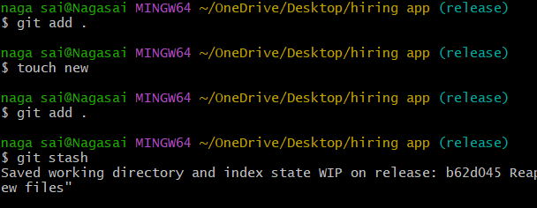

16.Undo the stash file and start working on that again.

Git stash pop :to undo the stash file

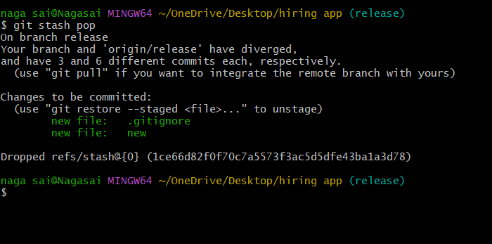

17.Generate a ssh-keygen and configure into github.

Ssh-keygen -t -rsa : to generate sshkey

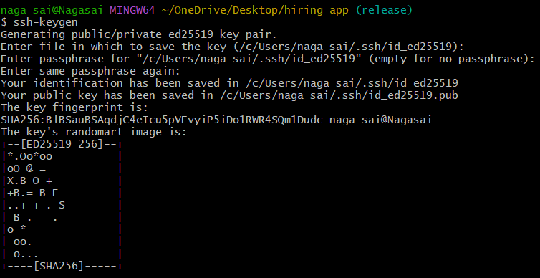

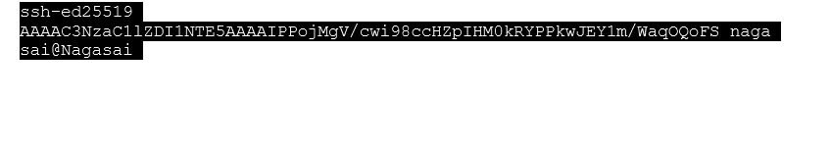Cat “path/to/key” : to view the sshkey

Copy the key

Add ssh key and confirm through the code and configuration is done.

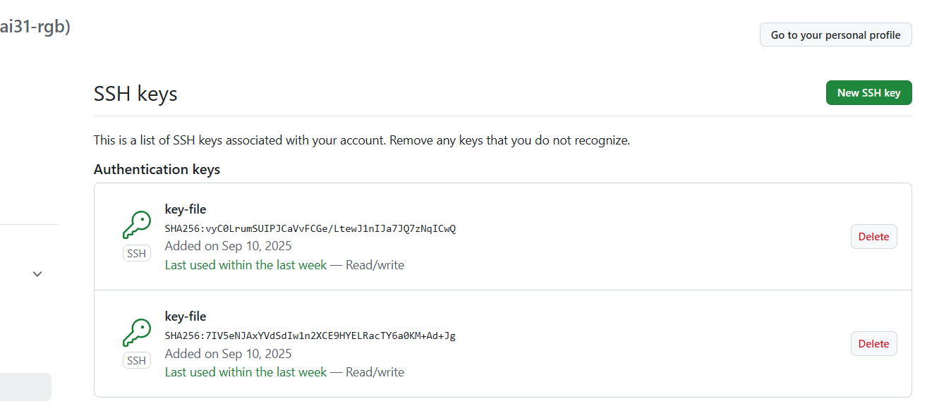

18. Configure webhooks to github

Click Add webhook.

After you create a new webhook, GitHub will send you a simple ping event to let you know you've set up the webhook correctly.

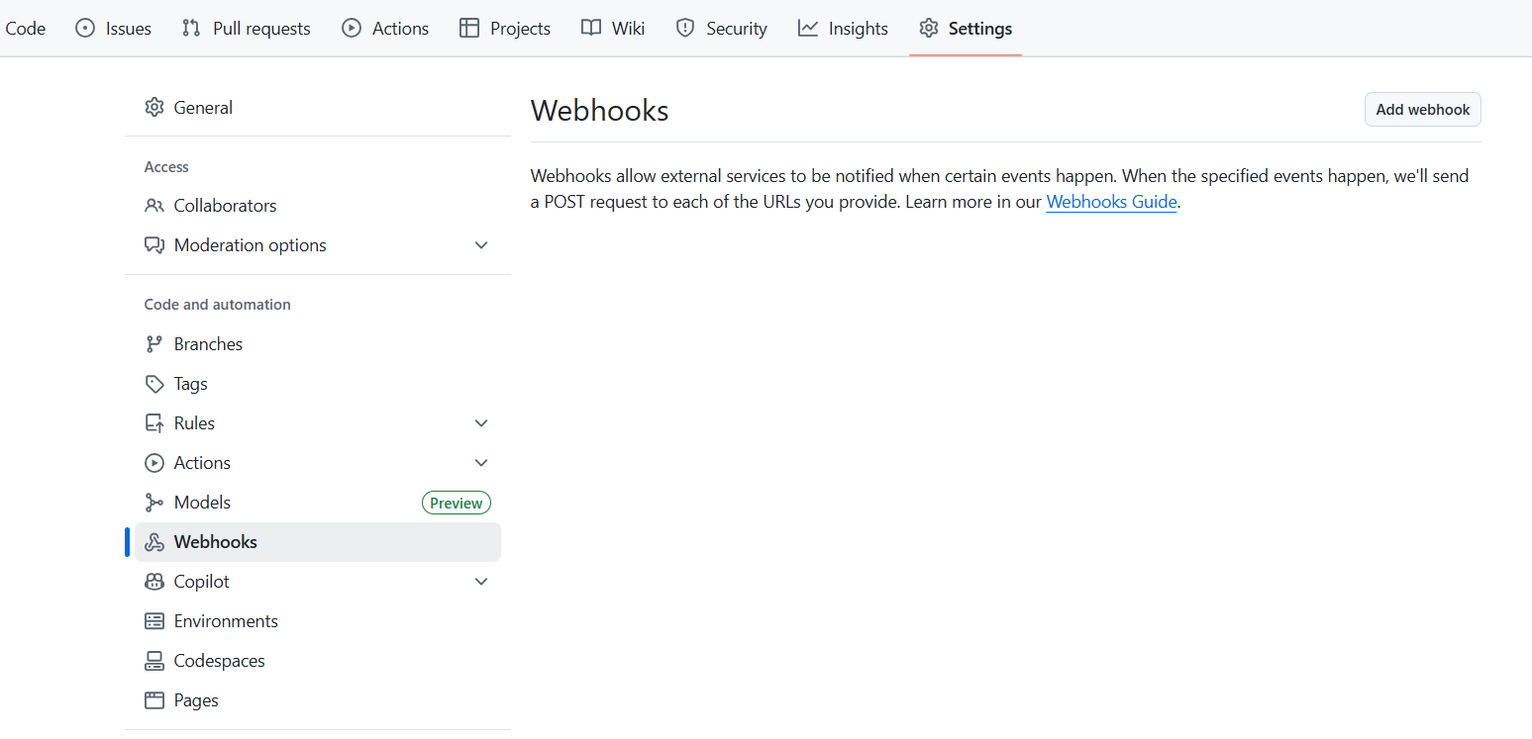

19. Basic understanding of .git file

The .git/ directory is the core component of a Git repository. It is a hidden directory located at the root of a Git-managed project and contains all the necessary information for Git to track changes, manage versions, and perform various operations. Essentially, it is where Git stores the entire history and metadata of your project.

20.Check all the logs of git.

Git log : to check all the logs

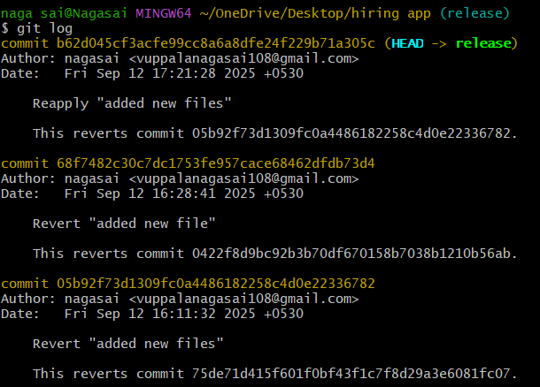

21..Rename the commit message.

Git commit - - amend : to change the commit message and save it

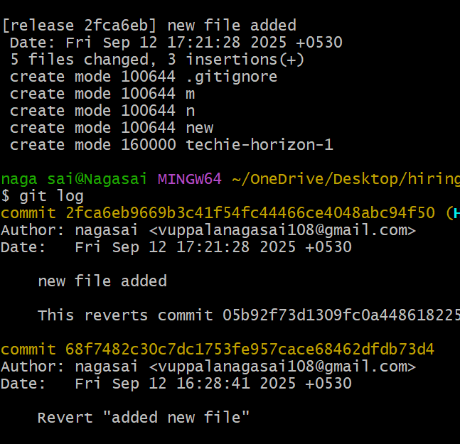

22.Merge multiple commits into single commit.

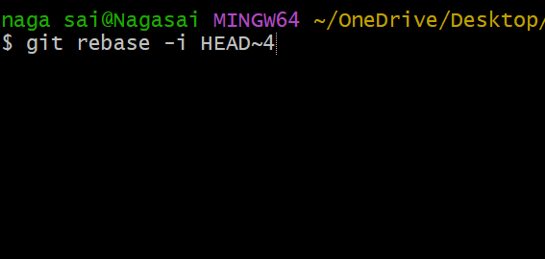

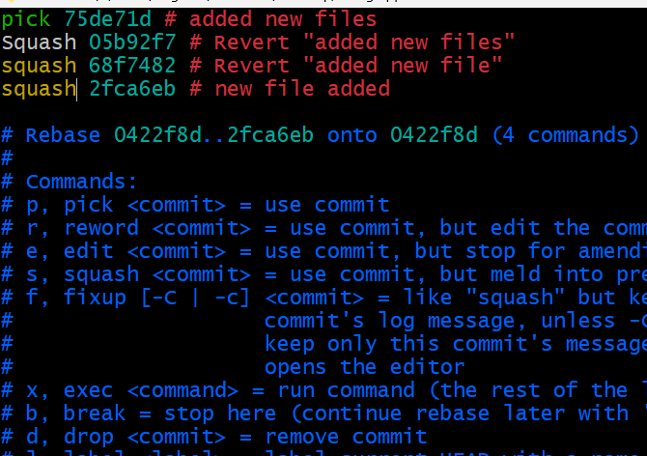

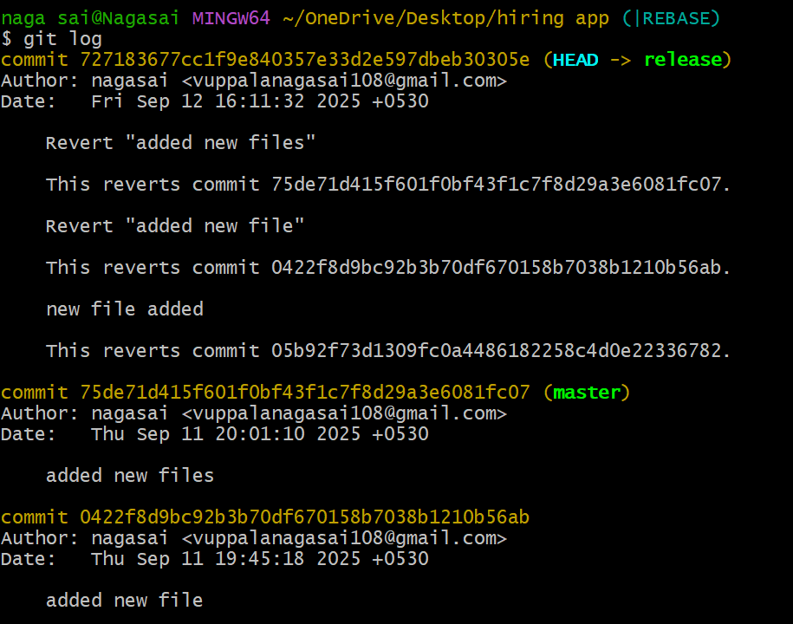

Edit and add the message and save it